Comment Sheet

YOUR NAME & ADDRESS:

EMAIL ADDRESS (if you would like to join our email list):

Thanks for your interest in where to construct an east-west neighborhood greenway in the Ballard neighborhood. Please fill out this comment sheet and help make walking and riding a bike safer and more comfortable.

1. Circle the streets you think would make the best neighborhood greenway route connecting to the Burke-Gilman Trail.

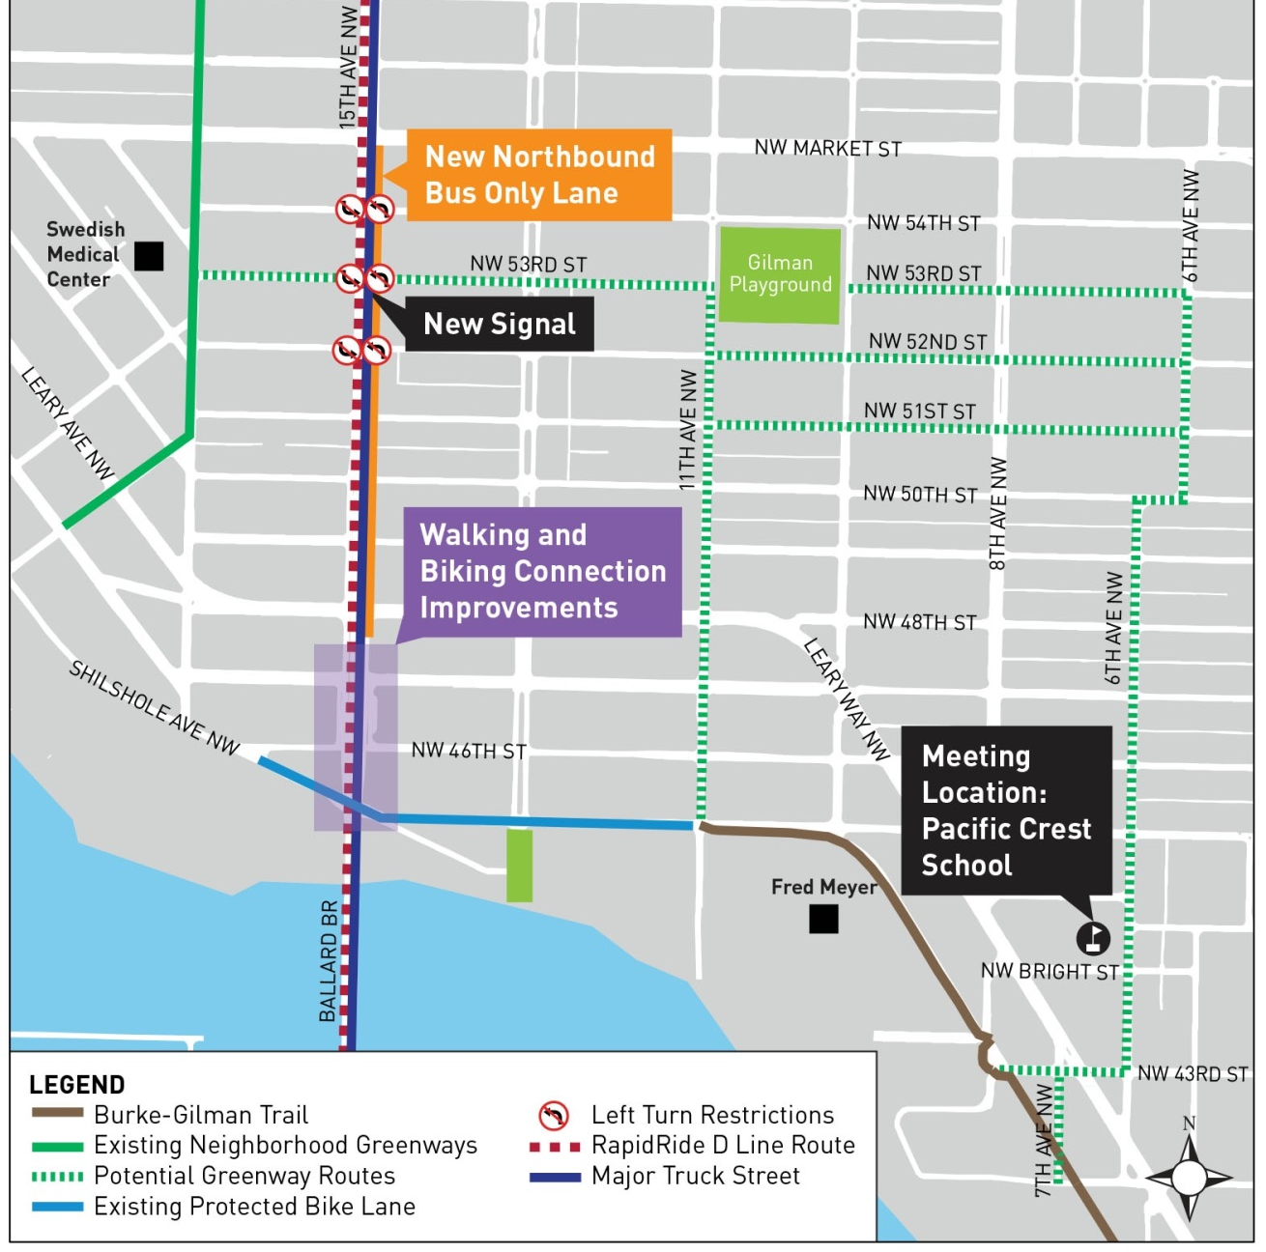

2. What barriers prevent, or make it more difficult, to walk and ride a bike in your neighborhood? Are there specific locations?

3. What are important destinations along the possible greenway route options?

4. Fire equipment, airline interiors and motor oil are manufactured along a portion of NW 53rd St among other industrial uses. What are your ideas for making the future traffic signal at 15th Ave NW easy to access by people walking and biking, while preserving important delivery, loading and unloading functions?

5. Additional comments?

Leave your comment sheet in the comment box tonight, or email your comment sheet to Summer.Jawson@Seattle.gov. An electronic version is available at www.seattle.gov/transportation/ballardgreenway.htm. You may also mail your comment sheet:

Summer Jawson
Seattle Department of Transportation
PO Box 34996
Seattle, WA 98124-4996

Please return all comments in by May 16, 2016.
Thank You!

